**Introduction**

**The Importance of Accounting**

**Accounting and Valuation**

**Accounting in the Present and the Future**

**To the Reader**

**A Road Map to the Book**

**Introduction**

**Fundamental Principles**

**Principles of Modern Finance**

***The No-Arbitrage Principle***

***Efficient Market Hypothesis***

***Value Is Based on Expected Cash Flows***

***Dividend Irrelevance: Value Does Not Depend on Dividend Payout***

***Diversification and Risk***

***Borrowing Does Not Add Value***

**The Products of Modern Finance**

***An Investment Strategy: Stocks for the Long Run***

***The Method of Comparable Multiples***

***Diversification in the Real Time***

***Asset Pricing Models***

***Growth and Value***

***Financial Engineering***

**Accounting for Value**

**Introduction**

***Good*** accounting supplies the anchor from which to challenge speculation in market prices. Analysts must avoid the trap of pretending they have precision, which they in fact lack. This is especially problematic when it comes to valuation since valuation is riddled with uncertainty. Assuming growth rates and applying CAPM to plug in discount rates exacerbates this uncertainty. We therefore must be honest in what we can do in handling uncertainty and what we cannot do. How do we circumvent these pitfalls?

**An Accounting Prototype**

The savings account is a simple instrument on which to test any valuation method. If the method does not work for a savings account, it will not work for equities.

*Figure 2.1 – Basic savings account with zero dividends (0% payout)*

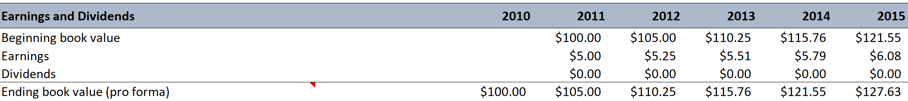

The savings account in Figure 2.1 is similar to corporations that we are trying to value:

1. On-going concern – the account doesn’t have an expiration date,
2. the payout rate determines what proportion of earnings are paid out as dividends; in Figure 2.1 the payout rate is 0%, that is all earnings are retained and reinvested and earn a rate-of-return identical to the rate-of-return on book value,
3. *the payout rate determines year-over-year growth rate in earnings and book value*,
4. the accounting numbers for the future – 2011 and beyond – are pro forma numbers where earnings are the bottom-line number from the pro forma income statement and book value of equity derives from the pro forma balance sheet.

This savings account is different from corporations, however, in that the pro forma is certain (riskless). The required rate-of-return for the investment (discount rate; ***hurdle rate***) is the risk-free rate. In this situation, the rate-of-return on book value and the hurdle rate are equivalent.

The current value of the savings account, $100, is the price at which it should trade if the market for savings accounts is efficient. The next step is to develop a valuation approach that arrives at that value.

***Value is based on expected future cash flows*** (modern finance principle). The problem with applying this approach to the basic savings account is that in the short and medium term there are no cash flows since dividends are zero. If we are adamant about using cash flows, then we must forecast long-term cash flows and this sort of forecast is strewn with uncertainty. Can we develop a valuation approach that focuses on the present rather than the distant future, that is, can we ***anchor on what we know rather than rely on speculation*** (fundamentalist principle)?

In Figure 2.2 all earnings are paid out as dividends – that is a savings account with 100% payout. In this account, expected cash flows are paid out in the short-term and hence we do not need to speculate. Notice that the book value today of both the 0% and 100% payout savings accounts is identical. This illustrates another principle of modern finance – ***value does not depend on cash payout***.

*Figure 2.2 – Basic savings account with all earnings paid out as dividends (100% payout)*

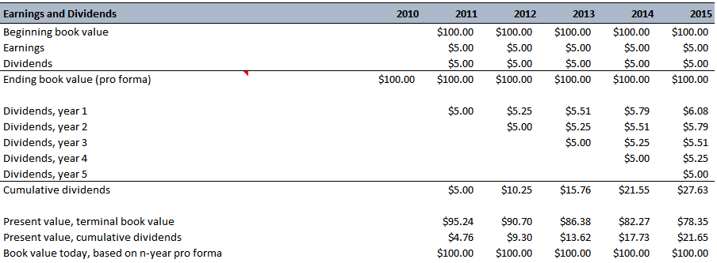

Value in both accounts is still based on expected cash flows over the life of the account. However, the timing of the payout is not relevant (cash flow is either paid in the form of dividends earlier or extracted from the book value in the long-term). This is the basic concept underlying Miller and Modigliani’s dividend irrelevance principle. However, this gives rise to the dividend conundrum – value is based on expected dividends but forecasting dividends typically does not give us much of a handle on the value.

In the short-term when there are no dividends, what other metrics can we use to estimate value? The answer lies in forecasting dividends **and** book value via the “stocks-and-flows” (also called the “clean surplus”) equation as encapsulated in Accounting Principle #1 below.

***Accounting Principle #1***

$$Future book value = Current book value + Future earnings - Future Dividends$$

Having done the accounting for future book value, the expected book value is then employed in valuation (by discounting the future book value to the present).

***Valuation Principle #1***

To get a handle on value, think of what the book value is likely to be in the future.

Putting Accounting Principle # 1 into context, in cases where the dividend payout rate is low, most of the future book value is generated by future earnings and within a five- and ten-year period, stock returns are largely explained by earnings that firms add to book value. This accretion of book value also represents a future source of dividends. When short-term consumption is increased through dividends, this compensation is charged against future book value. This dynamic is captured in Equation 2.1 below:

$${Equation 2.1 Value}_{0}=\frac{{Dividend}_{1}}{1+r} + \frac{{Dividend}_{2}}{{\left(1+r\right)}^{2}} + \frac{{Dividend}_{3}}{{\left(1+r\right)}^{3}} +… + \frac{{Dividend}_{t}}{{\left(1+r\right)}^{t}} + \frac{{Book}_{t}}{{\left(1+r\right)}^{t}}$$

We are going to tie the valuation method represented in Equation 2.1 with Equation 2.2 below:

$${Equation 2.2 Value}_{0} = Anchoring accounting value + Speculative value$$

$${Equation 2.3 Price}_{0} = {Book value}_{0} + Speculative value$$

Equation 2.3 is a reformulation of Equation 2.2. For the savings account with certain payoffs, the speculative value in Equation 2.3 is zero. Therefore, the price at which the savings account trades, and its value are both $100. This also results in a price-to-book ratio of 1. Furthermore, this suggests that when there is uncertainty, the P/B will be different than 1.

***Valuation Principle #2***

If one forecasts that the rate-of-return on book value will be equal to the required rate-of-return, the asset must be worth its book value.

Valuation Principle #2 ties another accounting measure, book rate-of-return, to valuation. It follows that an asset that is expected to earn a book rate-of-return greater than the investor’s required rate-of-return must be worth more than book value and vice versa.

$${Equation 2.4 Price}_{0} = {Book value}_{0} + Value for speculation about future book rate of return$$

**Cash Accounting for Value**

Discounted cash flow (DCF) analysis focuses on free cash flows (FCF). This technique is popular because some perceive accounting numbers as suspect whereas cash flows are “*real”*. Unlike forecasting pro forma income statements and balance sheets (both based on accrual accounting), DCF forecasts pro forma cash flow statements (cash accounting). When it comes to valuation, do we want cash accounting or accrual accounting? Equation 2.5 shows the DCF model using FCF:

$${Equation 2.5 Equity}_{0}=\frac{{FCF}_{1}}{1+r} + \frac{{FCF}_{2}}{{\left(1+r\right)}^{2}} +… + \frac{{FCF}_{t}}{{\left(1+r\right)}^{t}} + \frac{{FCF}_{t+1}}{{\left(1+r\right)}^{t}\left(r-g\right)} - {Net debt}_{0}$$

The DCF model attempts to finesse the dividend conundrum by focusing on cash flows generated within the firm rather than cash flows paid out of the firm to shareholders (dividends). This is good in a sense since it focuses on the generation of value rather than the distribution of value. However, is this good accounting for value?

The DCF model as shown in Equation 2.5 has several problems:

1. The valuation does not anchor on anything in the present (except for net debt),
2. the valuation involves the highly uncertain task of estimating continuing value that relies heavily on estimating the long-term growth rate,
3. since FCF is equal to cash flows from operations minus cash investments, subtracting cash investments often drives FCF negative and this can lead to a negative present value from FCF,
4. if the present value from FCF is negative, then the terminal value has to be greater than 100% of the current value and this embeds a high degree of speculation since terminal value is pegged to a long-term growth estimate that is highly uncertain.

The problem with DCF valuation is an accounting problem. FCF is more a liquidation concept than a measure of added value from increasing investments; hence FCF is not good accounting for value. Furthermore, growth in a continuing value is speculative and a valuation that rides on estimated growth is a risky valuation. It is better to anchor a valuation on something we can observe now or can predict confidently in the short-term. We want value justified by the facts. For that we need an alternative, less speculative accounting.

**Accrual Accounting for Value**

Accrual accounting reports earnings rather than cash flows. Does this mean that accrual accounting provides better accounting for value? Accrual accounting has two benefits:

1. Investments typically are not allowed to affect the value-added measure, earnings. Rather than being expensed against cash flow from operations, investments are booked to the balance sheet and hence to book value. As assets, investments are modelled as something that produces value in the future rather than as a detriment to value.
2. Cash flows from operations are modified by additional accruals. These accruals bring the future forward in time and reduce our reliance on speculative forecasts of the long-term.

Accrual accounting produces a book value, which one can potentially anchor on and also recognizes value when there are no cash flows.

***Accounting Principle #2***

Accrual accounting brings the future forward in time, anticipating future cash flows.

Accrual accounting is applied as a straightforward “correction” to cash flows. Accrual earnings from a business (before interest) is calculated in Equation 2.6 below:

$$Equation 2.6 Earnings before interest = Free cash flow + Investments + Added accruals$$

Investments and additional accruals are placed on the balance sheet so that book value consists of cash, debt, and business assets made up of investments and accruals. Therefore, while FCF are negative, the add back of investments and accruals often results in positive earnings and EPS and these positive earnings look like something we can anchor on when accounting for value.

The criticism here is that analyst may perceive cash flows as “real” and accounting numbers as “concocted”. The straight up expensing of R&D (shouldn’t R&D be considered an asset that increases future value) and Warren Buffet’s “owner earnings” versus GAAP depreciation are examples of wrinkles in accrual-based numbers versus cash flow-based numbers. This is why we must be concerned about how the accounting is done and not just take GAAP numbers at face value.

Accrual accounting brings the future forward in time, but one would not want to bring too much speculation about the future into the accounting – *understand what you know and separate it from speculation* (fundamentalist principle). Eschewing speculation is at the core of accounting for value. Is maintenance capital expenditure (ingredient that goes into Warren Buffets “owner earnings”) too much of a subjective notion to enter the accounting? Is GAAP depreciation, with its need to estimate useful lives of assets, too speculative?

**Adding Speculation to Book Value**

If valuation amounts to anchoring on book value and then adding speculation, we need guided and constrained discipline for adding speculation. Accounting supplies this discipline. One adds value to book value only if the expected rate-of-return on book value is greater than the hurdle.

$${Equation 2.6 Equity}_{0}=B_{0} + \frac{B_{0}\left({ROCE}_{1}-r\right)}{1+r} + \frac{B_{1}\left({ROCE}_{2}-r\right)}{{\left(1+r\right)}^{2}} + \frac{B_{2}\left({ROCE}_{3}-r\right)}{{\left(1+r\right)}^{2}\left(r-g\right)}$$

According to Equation 2.6, we anchor on the current book value then forecast earnings and book value over the next three years vis-à-vis pro forma balance sheets and income statements.

$${Equation 2.6a ROCE}_{t}= \frac{{Earnings}_{t}}{B_{t-1}}$$

$$Equation 2.6b B_{t-1}\left({ROCE}_{t}-r\right) = B_{t-1}{ROCE}_{t}-rB_{t-1}={Earnings}_{t}-rB_{t-1}={Abnormal Earnings}_{t}$$

Equation 2.6b represents residual earnings – also called excess earnings or abnormal earnings. ***The growth rate, g,*** is the rate at which abnormal earnings is expected to grow after year 3 (or the terminal year of the forecast period). Equation 2.6 can be presented in a compact alternate form by Equation 2.7 below:

$${Equation 2.7 Equity}_{0}=B_{0} + \frac{{AE}_{1}}{1+r} + \frac{{AE}_{2}}{{\left(1+r\right)}^{2}} + \frac{{AE}_{3}}{{\left(1+r\right)}^{2}\left(r-g\right)}$$

*Figure 2.3 – Valuing equity based on abnormal earnings at 50% payout rate*

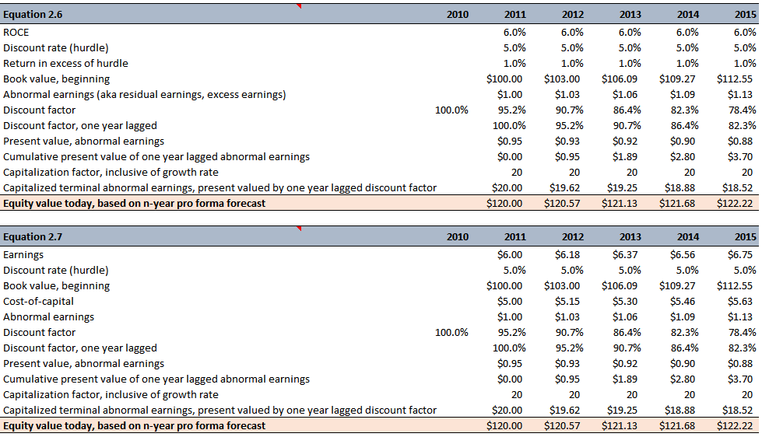

We can integrate the model represented by Equation 2.7 with the value derived by discounted dividends and book value calculated in Equation 2.1. This integrated model is shown in Equation 2.8 below:

$${Equation 2.8 Equity}_{0}= \frac{{Dividend}_{1}}{1+r} + \frac{{Dividend}_{2}}{{\left(1+r\right)}^{2}} + \frac{B_{2}}{{\left(1+r\right)}^{2}}+ \frac{{AE}_{3}}{{\left(1+r\right)}^{2}\left(r-g\right)}$$

*Equation 2.8 modifies Equation 2.1 to account for the ROCE being different from the discount rate.* This extra term equals the present value of the capitalized abnormal earnings for the last year in the forecast horizon. Equation 2.8 leads of Valuation Principle #3.

***Valuation Principle #3***

To get a handle on value, think first of what the book value is likely to be in the future and, second, what the rate-of-return on that book value is likely to be.

$${Equation 2.8a Equity}_{0}= \frac{{Dividend}_{1}}{1+r} + \frac{{Dividend}_{2}}{{\left(1+r\right)}^{2}} + \frac{B_{2}}{{\left(1+r\right)}^{2}}+ \frac{B_{2}\left({ROCE}_{3}-r\right)}{{\left(1+r\right)}^{2}\left(r-g\right)}$$

Valuation accounts for the future book value but also for future earnings on the book value, the ROCE at the forecast horizon. If ROCE is forecasted to be equal to the discount rate, the accounting has brought all value to be recognized into the value (Equation 2.1). If book value is not a complete accounting for value, further value is added by forecasting earnings on the book value (the last term in Equation 2.8a).

*Figure 2.4 – Valuing equity based on dividends and abnormal earnings at 50% payout rate*

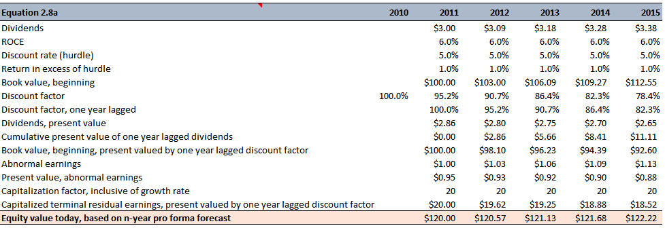

Figure 2.4 demonstrates that valuing equity with a focus on dividends is equivalent to value equity based on earnings and book value as demonstrated in Figure 2.3. The advantage of the the formulation represented in Figure 2.3 is that we can focus on accounting to arrive at short-term pro forma balance sheets and income statements as opposed to being dependent on dividends streams, that in the short-term may be non-existent.

Value is the present value of book value expected at the forecast horizon, plus the value of any intervening dividends, but with added value for the ROCE at which book values are expected to be earning at that point, in accordance with Valuation Principle #3. This formulation allows us to work with shorter forecasting horizons and with more assurance than we can with speculative long-term cash flows – **provided that the accounting is good accrual accounting**.

It is important to understand that the equity value derived using Equations 2.7 through 2.8 assumes a growth rate, g, of zero as explicitly shown in Equation 2.7a below:

$${Equation 2.7a Equity}_{0}=B_{0} + \frac{{AE}_{1}}{1+r} + \frac{{AE}_{2}}{{\left(1+r\right)}^{2}} + \frac{{AE}_{3}}{{\left(1+r\right)}^{2}×r}+Speculative growth$$

This is the valuation without growth, and it is a bedrock valuation per fundamentalist principles because it does not include value stemming from speculative growth – *beware of paying too much for growth*. In summary, we know the current book value (this comes from the current balance sheet) and if we have quality short-term accounting pro forma then these two components form the anchor for the valuation. This supports two more fundamentalist principles – *understand what you know and don’t mix what you know with speculation* **and** *anchor valuation on what you know rather than speculation*.

Let’s analyze the following information for GE’s common stock at the end of 1999:

*Figure 2.5 – Decomposition of GE’s stock price at the end of 1999*

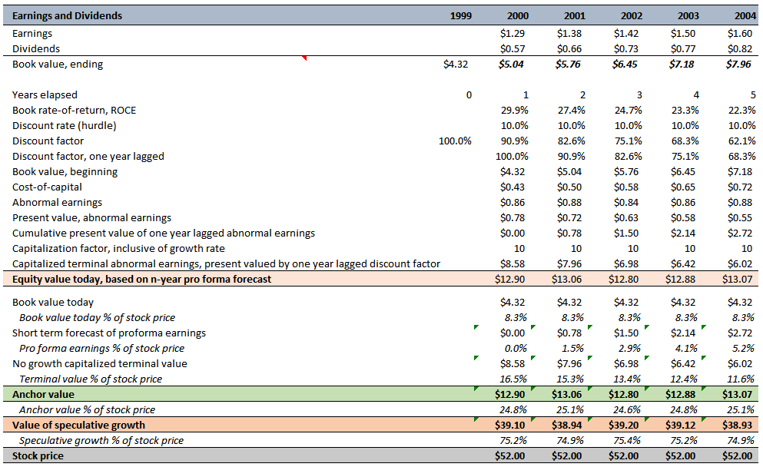

The three-year forecast (2002) suggests that we should be skeptical about 75% of the market price of equity. Either our accounting for value ($12.80) is missing a lot (or is flawed), the market is paying too much for growth, or we are missing something that the market sees regard growth potential.

From an ex-post perspective, the accounting for value showed little growth in abnormal earnings. Therefore, does the growth implied by the value of speculative growth in context to ex-post growth in abnormal earnings tell a consistent story? It is this notion that we must challenge.

The no-growth valuation means that abnormal earnings are deemed to continue at a constant level (with no growth) after the forecast horizon. Abnormal earnings is the product of ROCE and book value. In the GE’s case, ROCE decreased and book value (net assets) increased resulting in constant no-growth abnormal earnings. *To combat this, companies can attempt to generate abnormal earnings growth by figuring out how to increase profitability (ROCE) or growing the balance sheet (this will boost earnings despite constant or even declining profitability as long as the incremental asset earn a rate-of-return greater than the discount rate)*.

The bottom line is that one must have good reasons to add value stemming from speculative growth.

**Anchoring on Earnings: The P/E Ratio**

The equity valuation shown in Equation 2.7a focuses on book value and thus is centered on the P/B ratio. However, analysts usually think in terms of P/E multiples, earnings, and earnings growth rather than book value and abnormal earnings. Let’s transform Equation 2.7a to an equity valuation focused on P/E instead.

$${Equation 2.7a Equity}_{0}=B_{0} + \frac{{AE}_{1}}{1+r} + \frac{{AE}_{2}}{{\left(1+r\right)}^{2}} + \frac{{AE}_{3}}{{\left(1+r\right)}^{2}×r}+Speculative growth$$

$${Equation 2.9 Equity}_{0}=\frac{{Earnings}_{1}}{r} + \frac{1}{r}\left[\frac{∆{ AE}_{2}}{1+r} + \frac{∆ {AE}_{3}}{{\left(1+r\right)}^{2}} \right] + Speculative growth$$

Change in abnormal earnings is equivalent to abnormal earnings growth (AEG), which is earnings growth over and above growth at the hurdle rate.

$${Equation 2.10 AEG}_{t}=\left[{Earnings}_{t} + r×{Dividends}_{t-1}\right] - \left(1+r\right)×{Earnings}_{t-1}$$

$${Equation 2.11 AEG}_{t}=\left[E_{t} + rD_{t-1}\right] - \left(1+r\right)E_{t-1}$$

AEG compares the current year’s earnings with the previous year’s earnings growing at the hurdle rate. ***Earnings growth that exceeds the hurdle rate generates positive growth in abnormal earnings.*** However, we must be sensitive to the dividend payout rate when testing earnings growth relative to the hurdle. Let’s start by **setting AEG to zero** in Equation 2.11:

$$\left[E_{t} + rD_{t-1}\right] - \left(1+r\right)E_{t-1} = 0$$

$$E_{t} + rD_{t-1} = \left(1+r\right)E_{t-1}$$

$$\frac{E_{t}}{E_{t-1}} + r\frac{D_{t-1}}{E_{t-1}} = 1+r$$

$$\frac{E_{t}}{E_{t-1}}-1+ r\frac{D_{t-1}}{E_{t-1}} = r$$

$$Equation 2.12 Earnings Growth = r - r\frac{D_{t-1}}{E_{t-1}} = r\left(1-\frac{D_{t-1}}{E_{t-1}} \right)$$

Equation 2.12 connects earnings growth to the hurdle and dividend payout rate. Earnings growth that exceeds the hurdle adjusted for dividend payout will result in abnormal earnings growth. This adjustment accounts for dividend reinvestment and this is an important feature because shareholders derive earnings from two sources: earnings in the firm and earnings from reinvested dividends.

$${Equation 2.9a Equity}_{0}=\frac{{Earnings}_{1}}{r} + \frac{1}{r}\left[\frac{{ AEG}_{2}}{1+r} + \frac{{AEG}_{3}}{{\left(1+r\right)}^{2}} \right] + Speculative growth$$

Equation 2.9a is a simple rewrite of Equation 2.9. This valuation allows for growth in the short-term – that is the terms in the square bracket – but does not acknowledge growth in the long term. Let’s recast the value of equity with an accounting for dividends as shown in Equation 2.13 below:

$${Equation 2.13 Equity}_{0}=\frac{{Dividend}_{1}}{\left(1+r\right)} + \frac{{Dividend}_{2}}{{\left(1+r\right)}^{2}} + \frac{{EPS}_{3}}{{\left(1+r\right)}^{2}×r} + Speculative growth$$

Equation 2.14 below shows the standard model for the P/E ratio:

$${Equation 2.14 Equity}_{t}=\frac{{Earnings}_{t+1}}{\left(r-g\right)}$$

In this standard model the growth rate, g, is interpreted as the earnings growth rate. But this interpretation is problematic because earnings growth is usually near or exceeds the required rate-of-return. In this situation the standard model does not work because one does not buy earnings growth, one buys abnormal earnings growth – beware of paying too much for growth and definitely do not pay at all for an earnings growth rate that is less than the dividend adjusted hurdle rate.

The standard model will have you paying too much for growth. Both the AEG and the abnormal earnings model involve accounting that protects you from paying for growth when you should not. The way to protect yourself for paying for this growth is to set growth, g, to zero and move the assessment of growth to the speculative growth component of equation 2.13.

**Accounting for Value**

Equity investors should buy earnings because earnings move prices. When a firm’s earnings differ from expectation, stock prices change and in fact earnings explain most of the stock’s price movement over time – prices gravitate to earnings. In this chapter, we are separating what we know from speculation and establishing a starting point on which to anchor our valuation. What parts of equations 2.7a, 2.9a, and 2.13 represent the anchor and what parts represent speculation?

To carry out accounting for value, first think of where the book value is likely to be in the future and then what will be the likely earnings on book value. Also, when accounting for the future, understand what you are relatively certain about and that which is more speculative and translate the relative certain components into the accounting analysis – for example, modeling of sales drivers, profit margins, expenses, so on and so forth. This allows you to anchor on no-growth valuation and then focus on a rigorous assessment of growth prospects.

At this point the accounting for value is incomplete – what is the framework for adding value from speculative growth; how do we go about choosing a hurdle rate; what type of accounting is needed? If we desire accounting numbers to inform us about value, then these numbers must connect to the firm’s business activities that generate value. FCF does a poor job of making this connection. On the other hand, abnormal earnings valuation seemingly make the connection. Accrual accounting adds investment back to book value on the balance sheet and on top of that incremental value is added if superior returns are earned on this book value. The bottom line is that the accounting must be something to anchor on so we can challenge the speculation implied in the market price.

**Introduction**

One can think of valuation as a matter of accounting; however, accounting for value is incomplete. Good accounting minimizes speculation so that one can focus on challenging speculation in the market price.

**The Game of Investing**

Discard the idea of “intrinsic value”. Intrinsic value is an elusive concept and it’s a big mistake to imagine intrinsic value as definite and determinable like the market price. Valuation models should not be used as a method for determining a value but rather as a way to understand uncertainty about value.

Accounting identifies where our uncertainty lies – provided that we are confident in our accounting methodology. The value justified by the facts becomes the anchoring value. The difference between this value and the market price is where the uncertainty about growth resides. We therefore invest a lot of effort in challenging the appropriateness about this speculation on growth.

Equity investing is not a game against nature, but against other investors. From this perspective, investors should utilize valuation models to intuit how an investor thinks differently from other investors in the market. So ultimately the task isn’t to derive the “right” value but rather to draw insights aimed at understanding the embedded perceptions of other investors in the market price so that those perceptions can be challenged. This assessment of other investors’ perceptions centers primarily on other investors’ – collectively the markets’ – growth forecast underlying the valuation.

**Challenging Speculation in the Market Price**

In this section two questions are going to be ignored – 1) whether U.S. GAAP earnings is the appropriate accounting and 2) whether sell-side analysts’ forecasts provide a sound anchor. Analysts can be moved by speculation, offering optimistic forecasts in bull markets and overly pessimistic forecasts in bear markets.

We are going to use Cisco System’s pro forma earnings and dividends along with a hurdle rate of 10% to impute the market’s long-term growth rate expectations for Cisco at the end of 2009. Figure 3.1 shows Cisco’s pro forma and the derivation of the overall value derived from the anchoring value and from the speculative value. The analysis shown in Figure 3.1 is derived from Equation 2.7a

$${Equation 2.7a Equity}_{0}=B_{0} + \frac{{AE}_{1}}{1+r} + \frac{{AE}_{2}}{\left(1+r\right)×r}+Speculative growth$$

$$\$24.00=\$6.68 +\$0.68 + \$7.27+\$9.37$$

In the decomposition of Cisco’s value, we can see that 39% ($9.37 of the $24.00 market price) comprises speculative value. Notice that the growth rate of abnormal earnings is removed from Equation 2.7a. To figure out the markets implied growth rate, we have to reintroduce the growth rate back into Equation 2.7a. When this is done, we arrive back to Equation 2.7:

$${Equation 2.7 Equity}_{0}=B_{0} + \frac{{AE}_{1}}{1+r} + \frac{{AE}_{2}}{\left(1+r\right)\left(r-g\right)}$$

Based on the pro forma in Figure 3.1, we know all the variables in Equation 2.7 with exception to g. Therefore solving Equation 2.7 for the growth rate is straightforward.

*Figure 3.1 – Decomposition of Cisco’s stock price at the end of 2009*

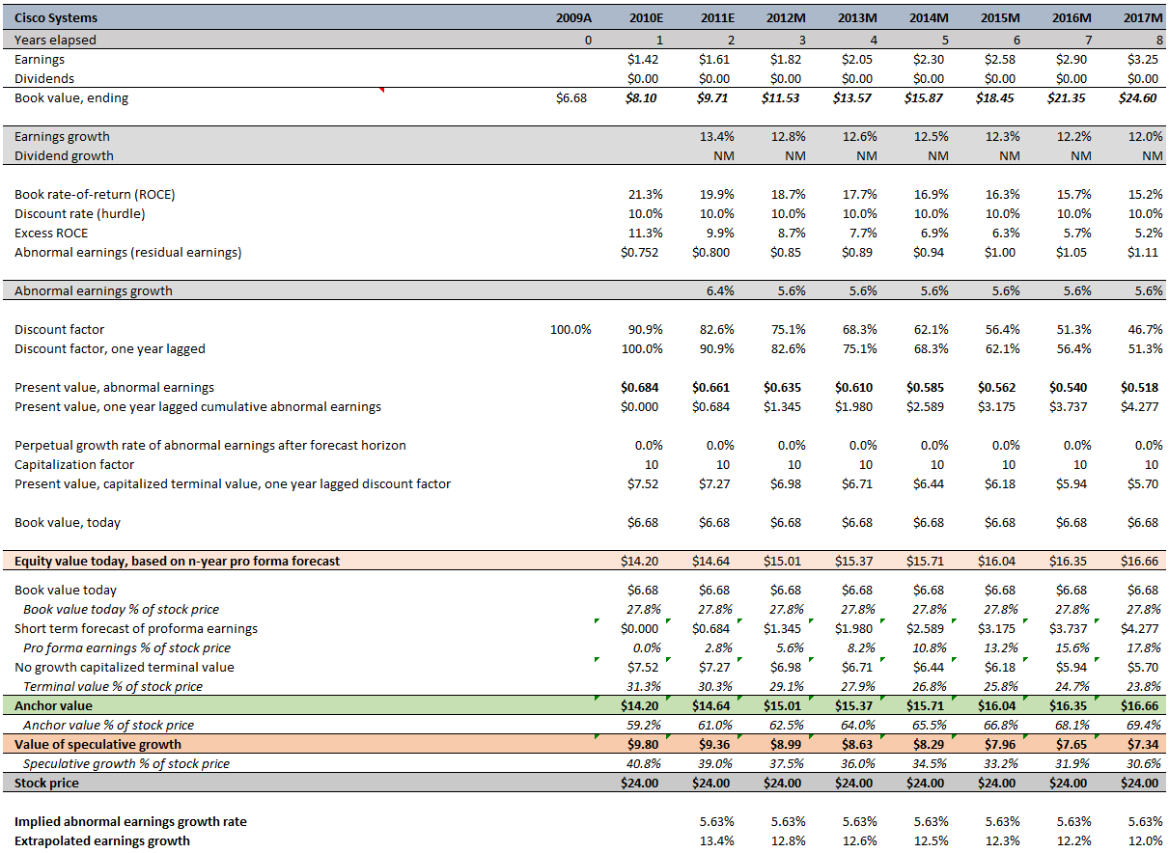

The implied abnormal earnings growth rate is backed out at the bottom of Figure 3.1. We have to be clear about what is involved in computing this implied rate. We are anchoring on the accounting in the book value and short-term forecasts, and only if we are reasonably confident in that accounting can we back out the growth rate that is implied.

Figure 3.1 demonstrates that the implied abnormal earnings growth remains constant. This is built into the model in Equation 2.7. However, implied abnormal earnings growth is difficult to grasp and this is why earnings growth predominates how analysts think about growth. The last line in Figure 3.1 shows how abnormal earnings growth and earnings growth are related.

$$Equation 2.6b {AE}_{t+1} = E_{t+1}-r×B_{t}$$

$$E_{t+1}= r×B_{t} + {AE}_{t+1}$$

$$\frac{E_{t+1}}{E_{t}}-1=Earnings growth = \frac{r×B_{t} + {AE}_{t+1}}{E_{t}}-1$$

Rather than trusting the market to deliver returns in the long run, the investor verifies whether the market’s forecast for the long run is reasonable. If you believe that a company’s growth will land above the implied earnings growth curve (last line in Figure 3.1) then the company lands within the “buy zone”. Conversely, if you believe the company’s growth will fall below the implied growth curve, then the company lands within the “sell zone”. To garner insights into what the expected growth will be, an accounting for growth must be performed.

To start, the investor looks at growth up to the forecast horizon as an indication of the firm’s ability to deliver subsequent growth. In the case of Cisco, the pro forma 2011 abnormal earnings growth is 6.4% contrasted with the markets’ implied long run growth rate of 5.6%. This is the issue that needs to be tackled and in order to do so a good knowledge of the company’s business is required. Does the company’s business model translate to 5.6% being a sensible or absurd growth rate for the long run?

Any growth forecast, and the added value it implies, must be justified with an accounting for what future book value and return on book value are likely to be. After all, in the long run, the market will price a firm based on its evolving financial statements. The investor recognizes that “sustainable competitive advantage” are only words unless supported by feasible forecasts of sales growth and profit margins.

***While remaining skeptical of prices, the investor also maintains respect***. A single analyst is not the sole possessor of knowledge and hence is wary of the dangers of self-deception and overconfidence. So just as import as the analyst challenging the market price is the notion of allowing the market price to challenge the analyst:

* “What do others know that I do not know?”
* “Is the market speculating about a takeover?”
* “Am I missing something?”

***The game is against other investors and the consensus view is to be acknowledged and understood***. Also remember that in deploying accounting as the anchor to challenge speculation, one must be realistic about whether the accounting has much to say. For example, you can’t use any of these tools for biotech startups since these ventures post losses and even negative book values in the short run!

**Benchmarking Growth**

*The No-Growth Benchmark*

The fundamentalist who refuses to pay for growth takes a firm stance: pay only the no-growth price. Pay only for the value justified by the accounting. In Figure 3.1 for Cisco this price would be $14.64 based on a two-year pro forma. If shares are trading at less than the no-growth price, the I am probably getting a bargain, for in all likelihood there is some growth. However this stance may just be too conservative. For instance, this strategy would have missed the “growth-stock” movement that took place during the 1950s.

*S&P 500 Growth Benchmark*

Similar to calculating the implied growth rate of abnormal earnings for stocks, you can also perform the same calculation for a broad market like the S&P 500.

***S&P 500 Growth Benchmark***

***Anchoring on Short-Term and Long-Term Growth: The Declining Growth Benchmark***

***The Risky Growth Benchmark***

**Accounting for Value and Accounting for Growth**

**Introduction**

Challenging the market’s growth forecasts requires an understanding of what drives growth. Supporting growth through “soft” concepts is not an entirely satisfactory check on speculation. Accounting can be employed to formulate a concrete expression of growth for value. An investor who is not attendant to the accounting can read false signals and pay too much for growth. There are two analytical steps for parsing sources of growth:

1. Accounting for growth derived from leverage or financing of the business.
2. Accounting for growth generated by the business itself.

The objective is to figure out how to account for growth in a way that clearly connects to value.

**Beware of Growth from Investment**

The idea that value accretive growth comes from investment opportunities is dangerous if left unchallenged. We can be more concrete by saying that investment adds value because it adds earnings or cash flows. However, investment that adds earnings growth may not add value.

Serial acquirer can generate considerable earnings growth but are those earnings generating value? Consider Tyco in the 1990s. Tyco drove up EPS growth primarily through acquisitive increases in book value (net assets). However, did this strategy deliver value to equity holders? To answer that we turn to accounting for value because it builds in protection from paying too much for growth since the focus is on residual earnings growth, not earnings growth. A firm delivers residual earnings only after covering the charge against the acquisitive investment that produces those earnings. If the incremental earnings from investment does not exceed this charge against investment, then the resulting negative residual earnings will destroy equity value.

***Valuation Principle #4***

*Growth that is valued does not come from earnings growth but from residual earnings growth.*

If a serial acquirer persistently pays fair value for acquisition, then value isn’t being created because fair value investments are earning, by definition, the hurdle rate-of-return. This problem is exacerbated when a serial acquirer persistently pays more than fair value. At this point, rational investors should question whether a company is hiding behind the cover of earnings growth. Also, investors must beware when management and consultants wrap nice-sounding business concepts around growth. Although entrepreneurs must think about and, on occasion, implement these concepts, they are mostly untested ideas that eventually must survive the test of time. Entrepreneurial ideas are the very essence of value creation, but one must be disciplined in embracing speculative ideas and the accompanying speculative growth that they are intended to bolster. Business concepts need to be challenged with an appropriate accounting, an accounting that protects the investor from paying too much for speculative growth.

Remember, when backing out the market’s implied growth rate based on your assessment of residual earnings growth, ask whether this implied growth is reasonable and if so, why is it reasonable. Look to ex-post residual earnings growth rates as well as peer and industry comparisons to support your assessment of reasonability.

**Beware of Earnings Growth and Profitability Generated by Leverage**

Leverage increase ROCE, EPS, earnings growth, and residual earnings, but it is very doubtful that it adds value – *beware of earnings created by leverage*.

Remember, when backing out the market’s implied growth rate based on your assessment of residual earnings growth, ask whether this implied growth is reasonable and if so, why is it reasonable. Look to ex-post residual earnings growth rates as well as peer and industry comparisons to support your assessment

**Accounting for Leverage**

**Stock Repurchases and Growth**

**Accounting for Growth from Leverage**

**Introduction**

**Beware of Profitability Generated by Accounting**

**Beware of Growth Generated by Accounting**

***Hidden Reserves and Liquidation of Hidden Reserves***

***Starbucks Corporation: A Promise of Growth***

**Accounting for Growth and Value**

**Accounting, Growth, and Risk**

**Introduction**

**The State of the Art: A Lament for Capital Asset Pricing**

**Finessing the Cost-of-Capital**

**Accounting for Risk**

***The Modernist Approach to Risk***

***Accounting Modeling of Risk***

**Accounting for Value**

**Introduction**

**Growth Versus Value**

***E/P and Risk***

***B/P and Risk***

***Words, Words, Words***

**E/P, B/P, and Accounting for Growth**

**Returns to “Value” and “Growth” Investing**

**Accounting for Value**

**Introduction**

**Historical Cost Accounting and Fair Value Accounting**

**Fair Value Accounting as an Anchor**

**When Is Fair Value Accounting Appropriate? The One-to-One Principle**

**Fair Value Accounting and Risk**

**A Lesson from Free Markets**

**The Misconception About Historical Cost Accounting**

***Microsoft Corporation***

***Dell Computer***

**Accounting for Value: A Balance Sheet Versus Income Statement Focus**

**Introduction**

**Returns to Penetrating the Accounting**

**What Is Good Accounting?**

**Caveat Emptor: What’s Wrong with GAAP?**

***The Balance Sheet***

***The Income Statement***

**Simplicity Is a Virtue, Complexity Is a Warning**

$${Equation A.1 Equity}_{0, n}=B_{0} + \left[\sum_{t=1}^{n-1}{\frac{B_{t-1}×\left({ROCE}_{t}-r\right)}{{\left(1+r\right)}^{t}}}\right] + \frac{B_{n-1}×\left({ROCE}_{n}-r\right)}{{\left(1+r\right)}^{n-1}\left(r-g\right)}$$

n years in the pro forma forecast horizon

B book value

ROCE rate-of-return on book value

$${ROCE}_{t}= \frac{{Earnings}_{t}}{B_{t-1}}=\frac{E_{t}}{B_{t-1}}$$

r hurdle rate (a.k.a. required rate-of-return)

g perpetual growth rate of abnormal earnings

-------------------------------------------------------- ◊ --------------------------------------------------------

$$Equation A.2 {AE}_{t} = B_{t-1}×\left({ROCE}_{t}-r\right) = B_{t-1}{ROCE}_{t}-r×B_{t-1} = E_{t}-r×B_{t-1}$$

AE abnormal earnings (a.k.a. residual earnings)

E earnings

-------------------------------------------------------- ◊ --------------------------------------------------------

$${Equation A.3 Equity}_{0,n}=B_{0}+ \left[\sum_{t=1}^{n-1}{\frac{{AE}_{t}}{{\left(1+r\right)}^{t}}}\right] + \frac{{AE}_{n}}{{\left(1+r\right)}^{n-1}\left(r-g\right)}$$

-------------------------------------------------------- ◊ --------------------------------------------------------

$${Equation A.4 Equity}_{0,n}= \left[\sum_{t=1}^{n-1}{\frac{D_{t}}{{\left(1+r\right)}^{t}}}\right] + \frac{B_{n-1}}{{\left(1+r\right)}^{n-1}} + \frac{{AE}_{n}}{{\left(1+r\right)}^{n-1}\left(r-g\right)}$$

D dividend

-------------------------------------------------------- ◊ --------------------------------------------------------

$${Equation A.3a Equity}_{0}=B_{0}+ \left[\sum_{t=1}^{n-1}{\frac{{AE}_{t}}{{\left(1+r\right)}^{t}}}\right] + \frac{{AE}_{n}}{{\left(1+r\right)}^{n-1}×r}+Speculative growth$$

-------------------------------------------------------- ◊ --------------------------------------------------------

$${Equation A.4a Equity}_{0,n}= \left[\sum_{t=1}^{n-1}{\frac{D_{t}}{{\left(1+r\right)}^{t}}}\right] + \frac{B_{n-1}}{{\left(1+r\right)}^{n-1}} + \frac{{AE}_{n}}{{\left(1+r\right)}^{n-1}×r} + Speculative growth$$

-------------------------------------------------------- ◊ --------------------------------------------------------

$${Equation A.5 Equity}_{0,n}=\begin{matrix}\frac{E_{1}}{r} + \frac{1}{r}×\sum_{t=2}^{n}{\frac{{AE}_{t}-{AE}_{t-1}}{{\left(1+r\right)}^{t-1}}} + Speculative growth & n≥2 \\ \frac{E_{1}}{r} & n=1\end{matrix}$$

$${Equation A.6 AEG}_{t} = {AE}_{t} - {AE}_{t-1}= \left[E_{t} + r×D_{t-1}\right] - \left(1+r\right)×E_{t-1}$$

AEG abnormal earnings growth

-------------------------------------------------------- ◊ --------------------------------------------------------

$$Equation A.7 Required earnings growth = r - r×\frac{D_{t-1}}{E_{t-1}} = r×\left(1-\frac{D_{t-1}}{E_{t-1}} \right)$$

-------------------------------------------------------- ◊ --------------------------------------------------------

$${Equation A.5a Equity}_{0,n}=\begin{matrix}\frac{E_{1}}{r} + \frac{1}{r}×\sum_{t=2}^{n}{\frac{{AEG}_{t}}{{\left(1+r\right)}^{t-1}}} + Speculative growth & n≥2 \\ \frac{E_{1}}{r} & n=1\end{matrix}$$

-------------------------------------------------------- ◊ --------------------------------------------------------

$${Equation A.8 Equity}_{0,n}=\begin{matrix} \left[\sum_{t=1}^{n-1}{\frac{D_{t}}{{\left(1+r\right)}^{t}}}\right] + \frac{{EPS}_{n}}{{\left(1+r\right)}^{n-1}×r} + Speculative growth & n≥2 \\ \frac{E_{1}}{r} & n=1\end{matrix}$$

-------------------------------------------------------- ◊ -------------------------------------------------------